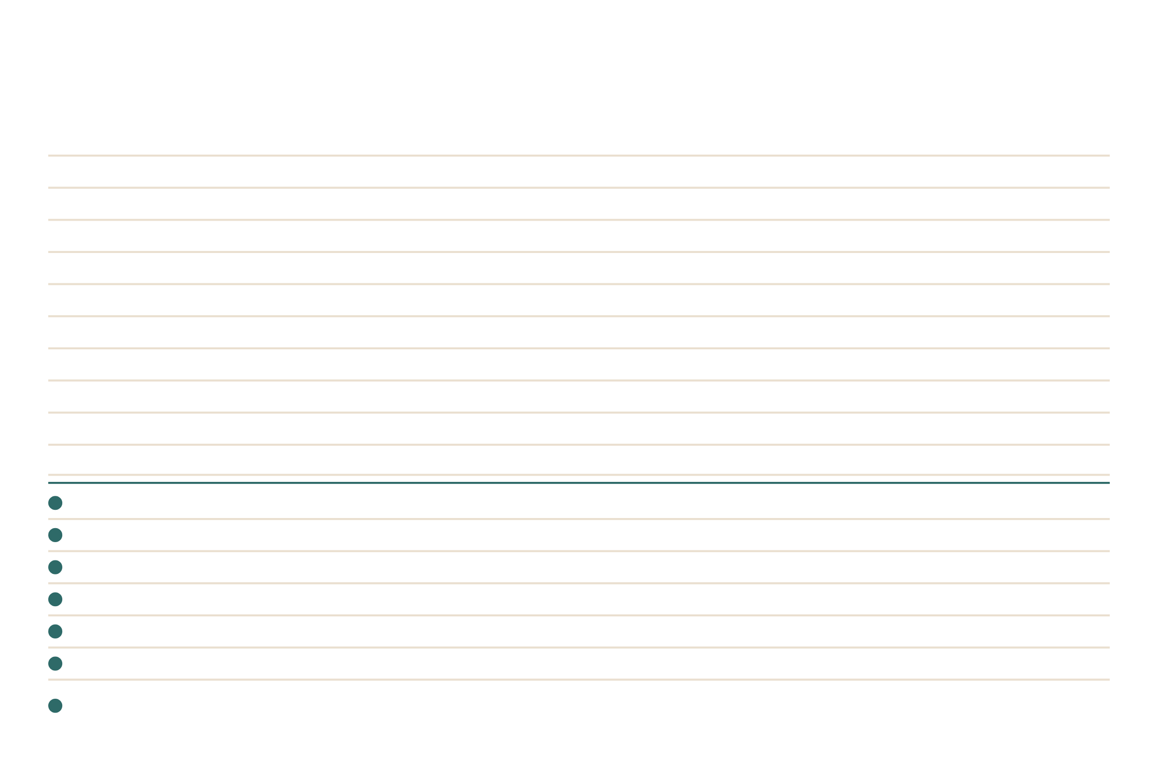
Specialty Drinks
Apple Pie
apple, brown sugar cinnamon, and vanilla
Black Squirrel
chocolate, hazelnut, and almond
Blonde
white chocolate, caramel, and toasted marshmallow
Blueberry Pie
blueberry, brown sugar cinnamon, and vanilla
Caramel Kiss
caramel and French vanilla
Fluffernutter
peanut butter and toasted marshmallow
Honeybee
honey, rose or lavender, and vanilla
London Fog
Earl Grey tea, vanilla, lavender, and steamed milk
Nutty Monkey
caramel, banana, and peanut butter
Peppermint Patty
chocolate and peppermint
Turtle
chocolate, caramel, and toffee
Book Worm
brown sugar cinnamon, vanilla, caramel, and cold foam
Detention
cookies & cream, white chocolate, vanilla, and whipped cream
Hall Pass
peach, coconut, lime, and Starry
School Spirit
blue raspberry, strawberry, coconut, and Red Bull
Straight A's
strawberry, blue raspberry, lime, and Red Bull
Teacher's Fuel
vanilla, caramel, hazelnut, and white chocolate
Seasonal
As a latte, macchiato, frappe, shaken espresso, or cold brew
Prices on the menu · build your own on the back
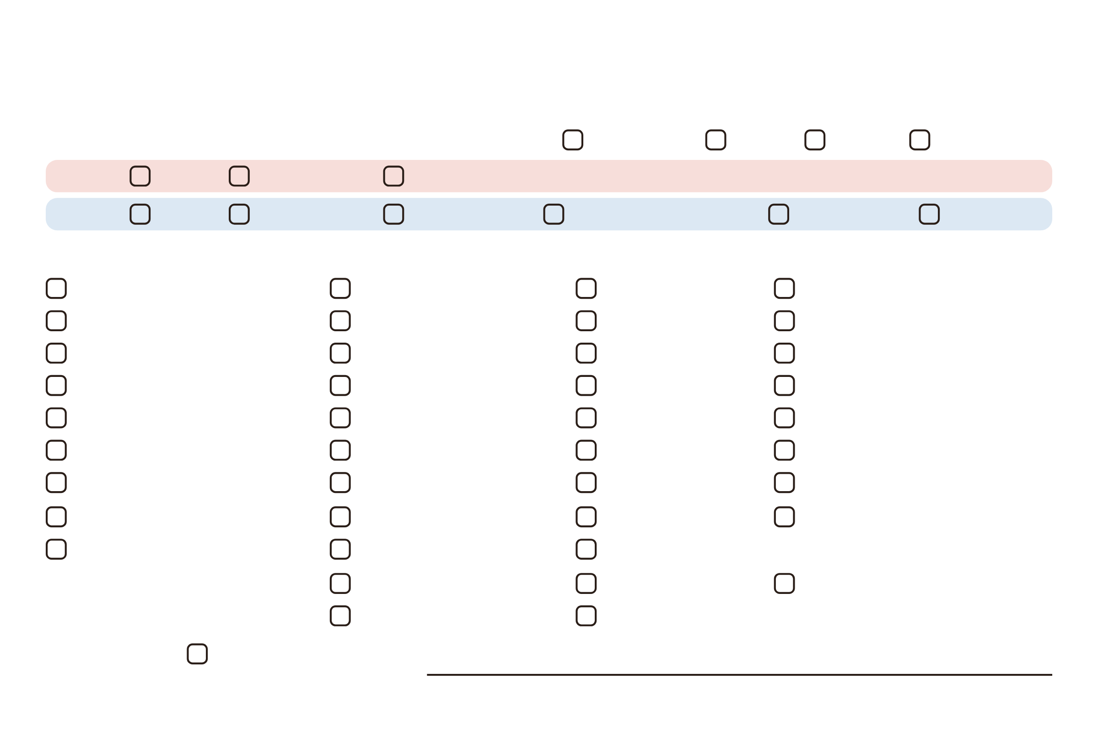
Build Your Drink
1
Pick a drink and size
12 oz, hot
16 oz
20 oz
32 oz, iced
HOT
Latte
Macchiato
Americano
ICED
Latte
Macchiato
Americano
Shaken espresso
Cold brew
Frappe
2
Pick your add-ins
3 included · extras +1.25 each
Almond
Apple
Banana
Blue raspberry
Blueberry
Brown sugar cinnamon
Butter pecan
Chai
Cherry
Cinnamon
Coconut
Crème de menthe
English toffee
French vanilla
Hazelnut
Honey
Irish cream
Lavender
Peach
Peanut butter
Peppermint
Raspberry
Rose
Salted caramel
Strawberry
Toasted marshmallow
Vanilla
White chocolate
Caramel sauce
Mocha sauce
Oat milk
White chocolate sauce
Extra espresso shot
Almond milk
Cold foam
SUGAR-FREE
Pumpkin pie
Vanilla bean
Brown sugar cinnamon
White chocolate
French vanilla
3
Finish it
Whipped cream
Name
TKB DINER

